LAB ACTION PLAN FOR WEEK 6
Objectives:
Students will able to:
- Learn how to define and run multiple interdependent services (e.g., web server, database) in a single configuration file.
- Gain skills in writing and interpreting docker-compose.yml files for service setup.
- Deploy the same setup across different machines without manual configuration.
- Configure container networking and persistent storage within Compose.
- Reduce setup time and enable faster iteration during application development.
Students will perform Hands-on running multi container applications using docker compose and make document that include the execution of each step along with scenario-based question solutions after completing the tasks.

What is Docker Compose?
Docker Compose is a tool used to define and run multi-container Docker applications. It allows you to define services, networks, and volumes that your application needs, all in a single file. This makes it easier to manage complex applications that require multiple containers (e.g., a web server and a database).

Structure of a Docker Compose File
A Docker Compose file is written in YAML (YAML Ain't Markup Language), a human-readable data format used for configuration. In the Docker context, it helps define the services, networks, and volumes needed for an application.

Basic Components of a Docker Compose YAML File
- Version: Specifies which version of the Docker Compose file format you're using. Each version comes with its own set of features.
version: '3.8'

- Services: This section defines all the containers you want to run for your application. Each service represents a container (like a web server or database).
Each service includes:
  - Image: The Docker image to use.
  - Ports: Ports to map between the container and your host machine.
  - Environment: Environment variables required by the service.
  - Dependencies: Which other services a container depends on.
Example:

services:
web:
image: nginx
ports:
- "8060:80"
db:
image: tomee
ports:
- "8050:8080"

- Networks: Define networks to allow different services to communicate with each other. Docker Compose automatically creates a default network if not specified.

- Volumes: Used for persistent storage, allowing data to persist even after the container stops or is removed.

Example Docker Compose File (Simple)
Here’s a basic example of a Docker Compose file that runs WordPress and MySQL together:
version: '3.8' # Docker Compose file format version

services:
wordpress: # WordPress service
image: wordpress:latest
ports:
- "8080:80" # Map port 80 of the container to port 8080 of the host
environment:
WORDPRESS_DB_HOST: db:3306 # Database host
WORDPRESS_DB_USER: wordpress
WORDPRESS_DB_PASSWORD: wordpress
WORDPRESS_DB_NAME: wordpress
depends_on:
- db # Ensures the db service starts first

db: # MySQL service
image: mysql:5.7
environment:
MYSQL_ROOT_PASSWORD: rootpassword
MYSQL_DATABASE: wordpress
MYSQL_USER: wordpress
MYSQL_PASSWORD: wordpress

How to Run It
To run a multi-container setup like the one above:
- Save the file as docker-compose.yml.
Or
docker-compose.yaml
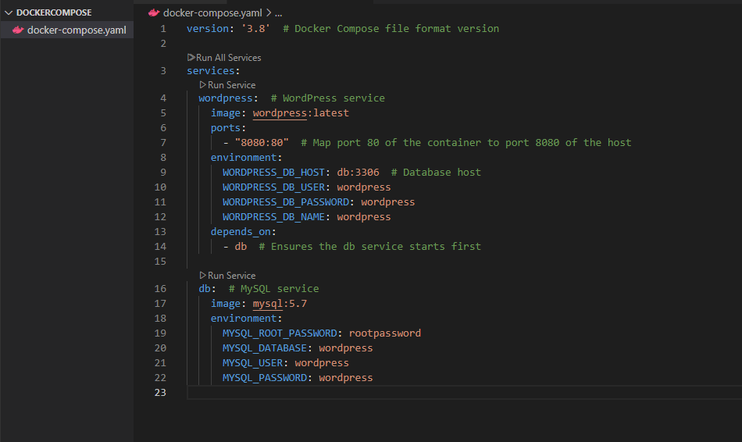
- To Start the compose

docker-compose up –d
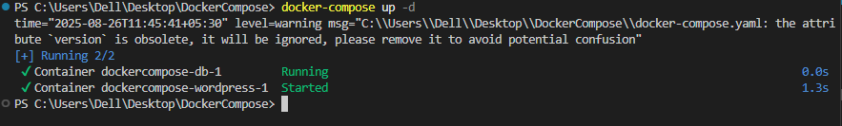
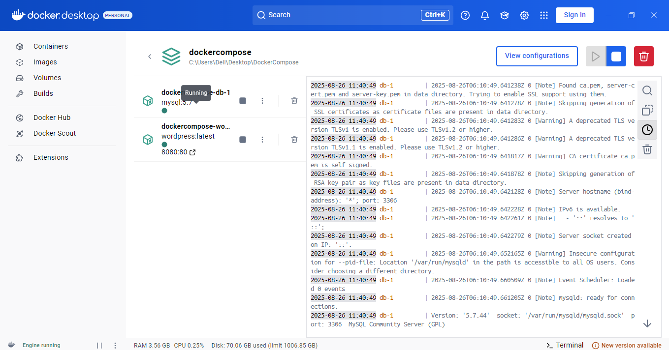

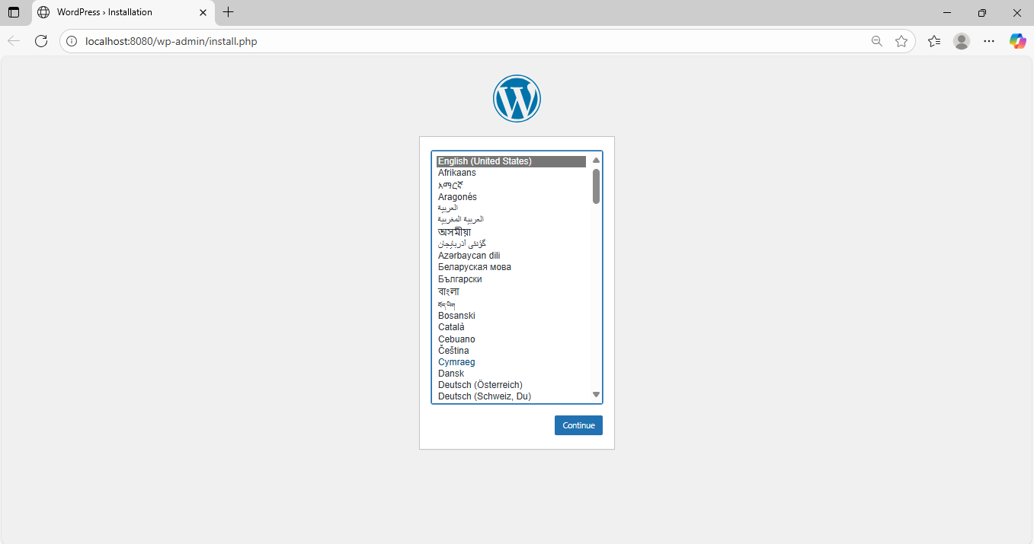
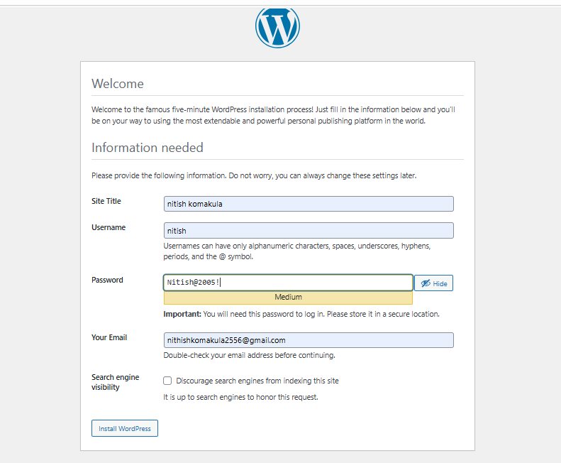


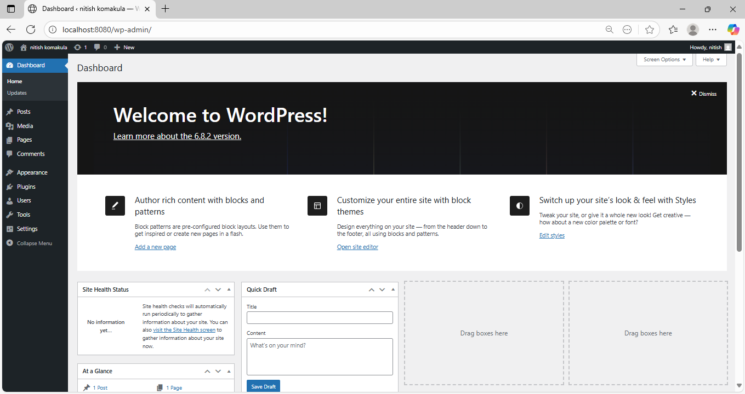

- To stop the containers
docker-compose down
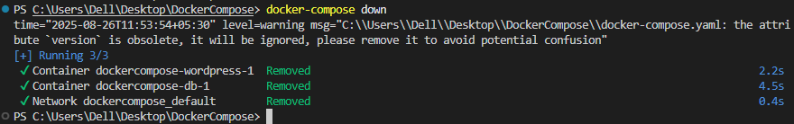
- To scale the container

docker-compose up --scale <service name>=2 -d

1.Define and run multiple interdependent services

Task:
- Create a new folder compose-lab
Inside it, create a file docker-compose.yml with the following content:

version: "3.9"
services:
web:
image: nginx:latest
ports:
- "8080:80"

db:
image: postgres:15
environment:
POSTGRES_USER: demo
POSTGRES_PASSWORD: demo
POSTGRES_DB: demo_db

II. Run the setup:

docker compose up -d
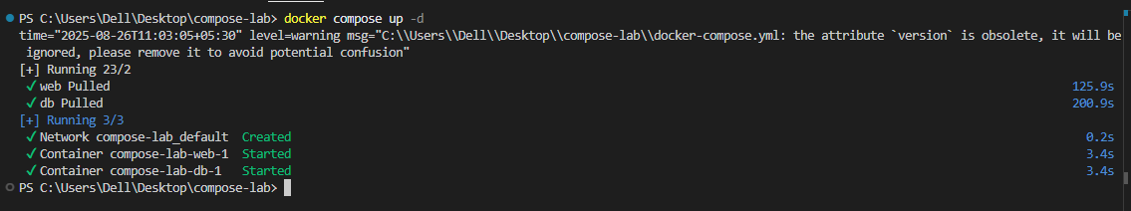

III. Open your browser and visit: http://localhost:8080.

IV. Expected Output:

Nginx welcome page is displayed.
db container runs in the background.


2.Write and interpret docker-compose.yml files
Task:
- Modify docker-compose.yml to add a Redis cache:

redis:
image: redis:alpine

II. Add a depends_on so web waits for Redis:
web:
image: nginx:latest
ports:
- "8080:80"
depends_on:
- redis

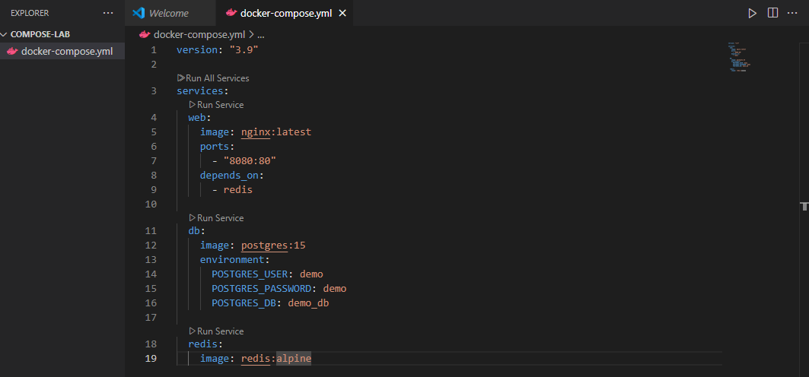
III. Restart the setup:
docker compose up -d
docker compose ps
IV. Expected Output:
Three services (web, db, redis) are listed as running.
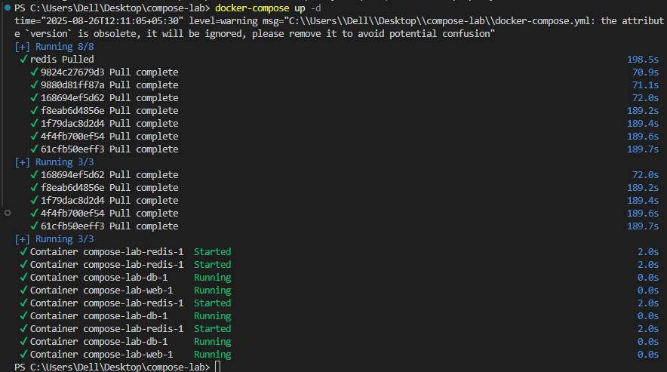

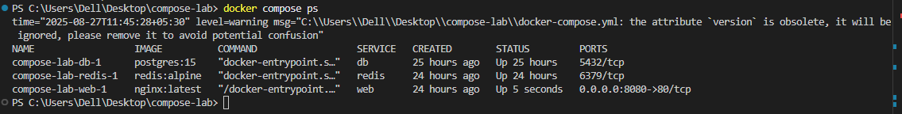

3.Deploy across different machines
Task:
- Zip your compose-lab folder.

Transfer it to another machine with Docker Compose installed.

II. Run:
docker compose up -d

Check that Nginx and Postgres work there as well.

III. Expected Output:
The same services run on the new machine without changes.
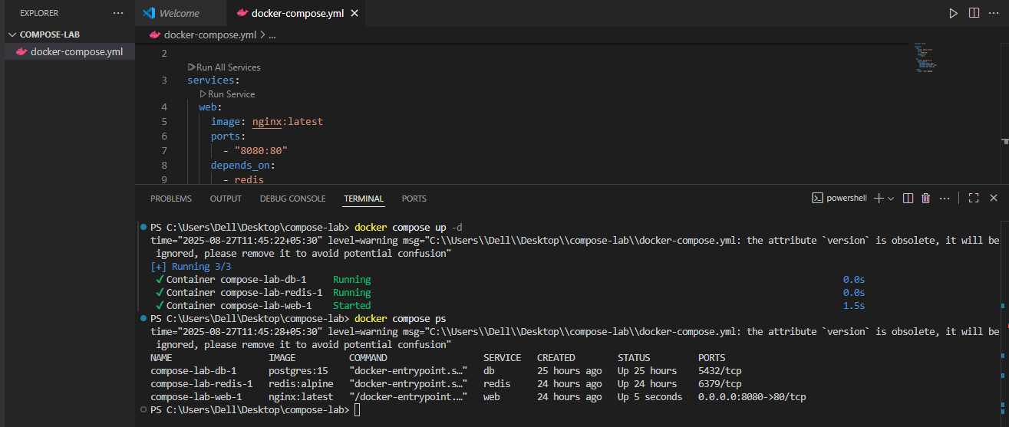

4.Networking and persistent storage
Task:
- Update your docker-compose.yml to add a custom network and volume:

networks:
app-net:

volumes:
db-data:

services:
web:
image: nginx:latest
ports:
- "8080:80"
networks:
- app-net
depends_on:
- db

db:
image: postgres:15
environment:
POSTGRES_USER: demo
POSTGRES_PASSWORD: demo
POSTGRES_DB: demo_db
volumes:
- db-data:/var/lib/postgresql/data
networks:
- app-net
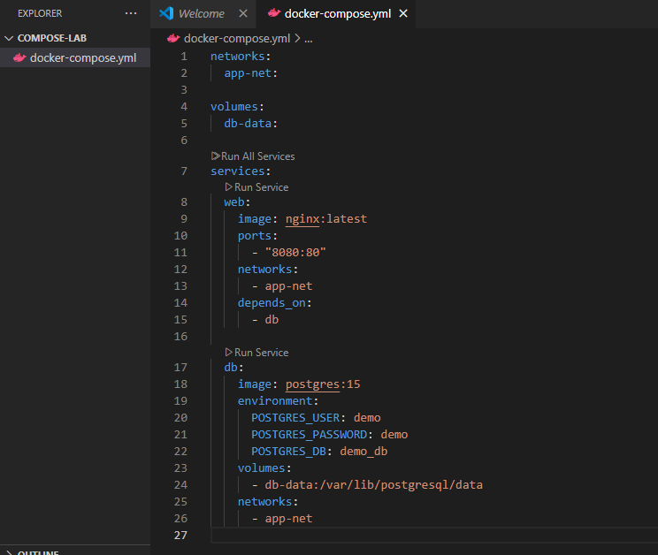

II. Run:
docker compose up -d
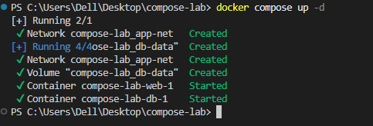
III. Insert some data into Postgres (optional with psql).
IV. Remove containers:
docker compose down
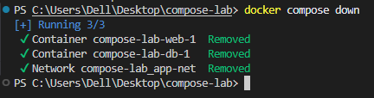
V. Start again:
docker compose up -d
VI. Expected Output:
Database data persists across restarts.
Services communicate via the app-net network using service names.
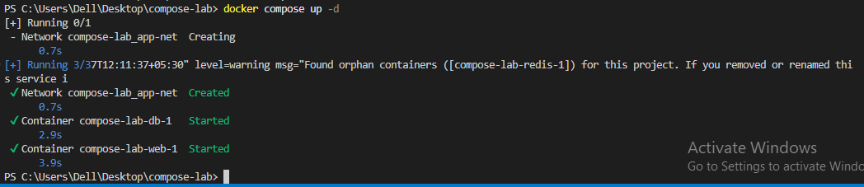

5.Faster iteration during development
Task:
- Create a simple Flask app in app.py:

from flask import Flask
app = Flask(__name__)
@app.route("/")
def home():
return "Hello from Flask + Docker!"
if __name__ == "__main__":
app.run(host="0.0.0.0", port=5000)
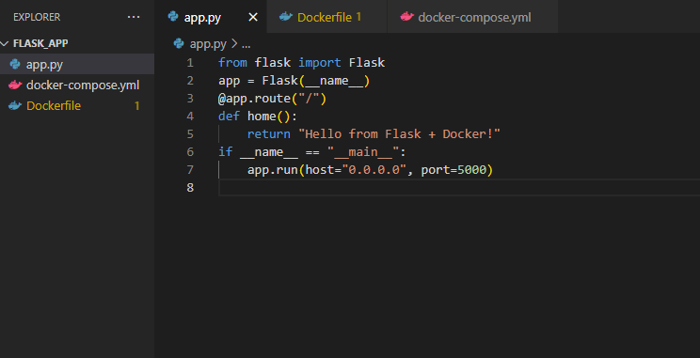

II. Add a Dockerfile in the same folder:

FROM python:3.10-slim
WORKDIR /app
COPY app.py /app/
RUN pip install flask
CMD ["python", "app.py"]
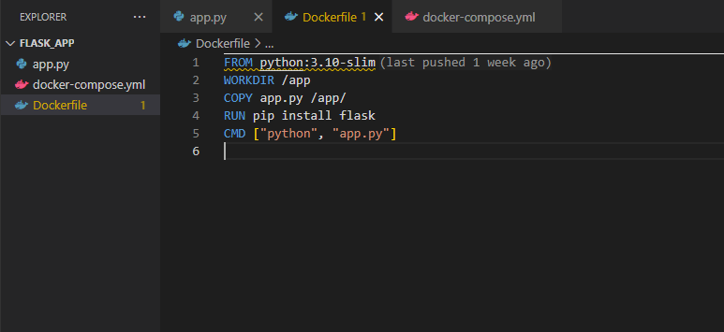

III. Update docker-compose.yml:
web:
build: .
ports:
- "5000:5000"
depends_on:
- db
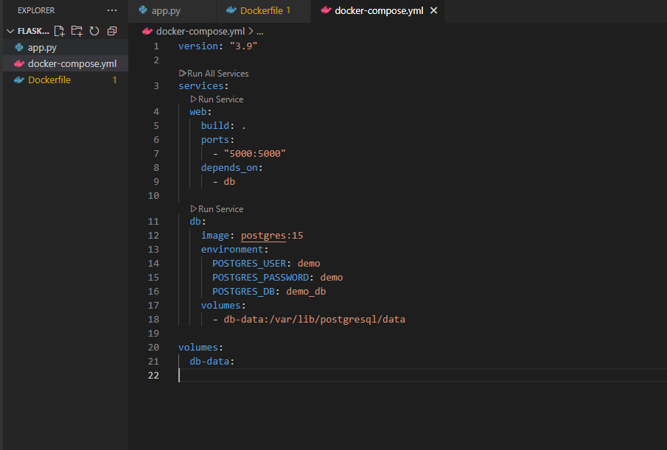
IV. Run:
docker compose up –build
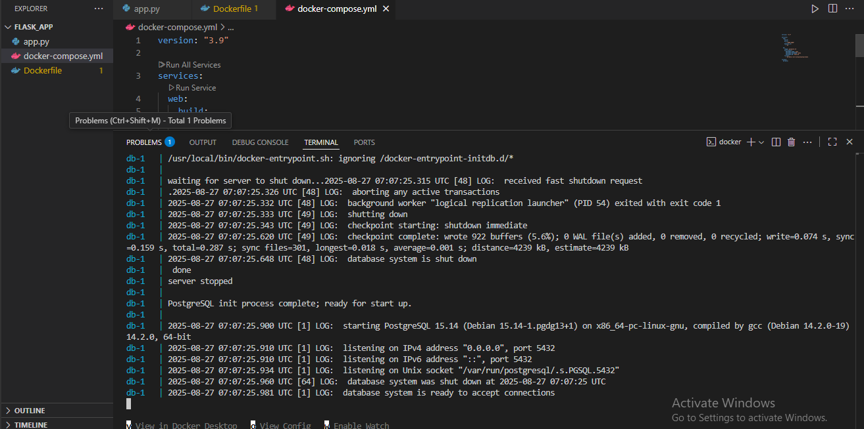
Visit http://localhost:5000.

Change the return text in app.py (e.g., "Hello Docker Compose!").
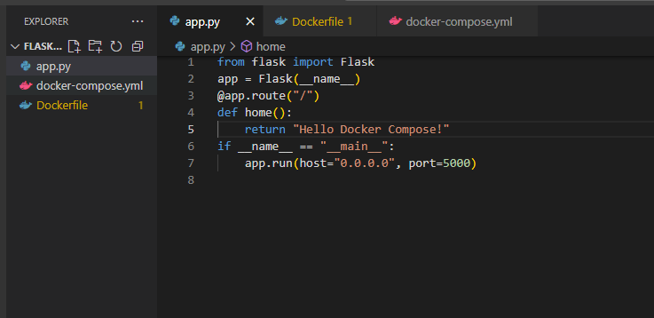
V. Rebuild:
docker compose up –build
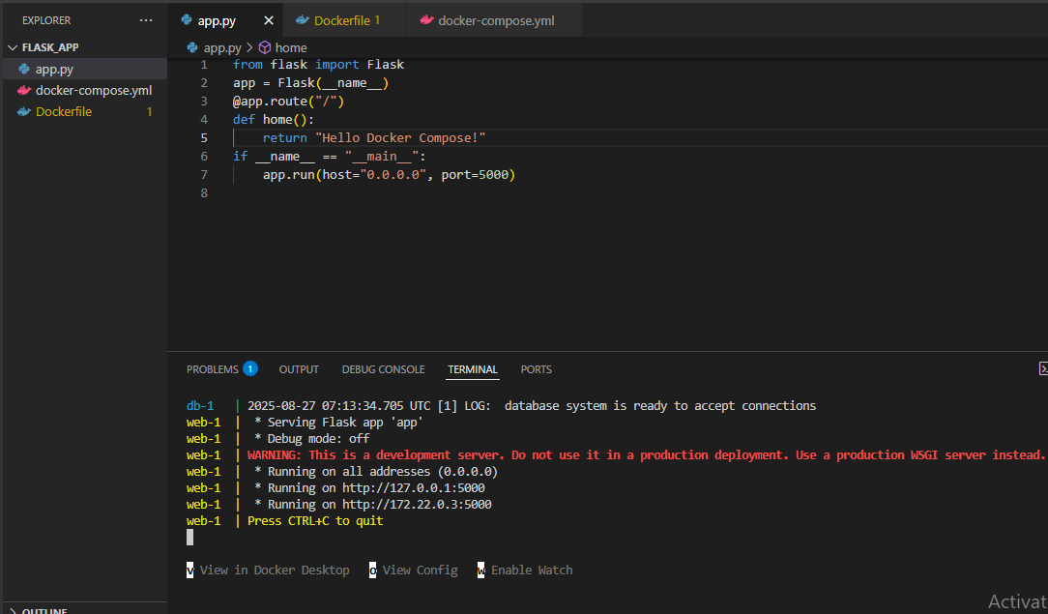
VI. Expected Output:
New message appears instantly after rebuild.
